I choose to live a life beyond a mere existence. I don’t want to sit on the couch, I want to experience the world to my fullest potential. I want to be a role model and I want people to know they can accomplish extraordinary things.
“
April 7th, 2021
Dear Friend,
Growing up with a degenerative eye disease, I heard my fair share of “you can’t do that because you can’t see well.” I’ve been legally blind for over twenty years now, and that same discouraging statement has followed me around for as long as I can remember.
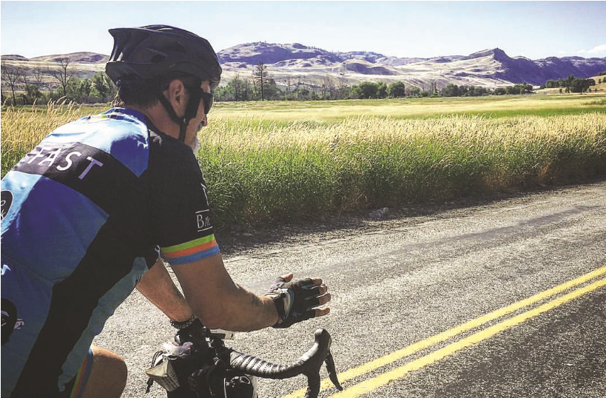
You see, as a kid, my bicycle was always my refuge. My peers could be cruel due to my visual impairment, and biking was something I could do independently. One day I caught up to a man on his bike who told me he was riding straight through to Florida. Ever since then, it became my goal to make a cross country trip.
I am so grateful for people like you. As an impressionable teen, I heard my first “yes, you Michael riding his bike on the open road.
“
can” during my summer at The Iris Network,
where I received an evaluation and took part in outdoor activities. I made friends and a lifelong connection to the organization and the work they do. I was inspired.
Gifts from people like you to The Iris Network enable them to provide critical services and education to people with vision loss—the kind of support that empowers us to enjoy our lives, go to work, achieve our goals, and be productive and fulfilled.
Will you please show your support with a gift to The Iris Network today, and be the positive encouragement these people need?
As I grew older, began my career, and started a family, my bike collected some dust in the garage. When we moved to Augusta, Maine, my eyes lit up when I saw a three-day bike ride across the state with 1,000 cyclists. My dream of a cross-country ride was renewed, and it was time to start planning.
In 2017, I challenged myself and anyone who had told me “no you can’t” by biking across the United States, from the Pacific Ocean to Portland, Maine.
(over, please)
I knew I’d need a partner who I could train with and shadow ride behind. I’d have to gather equipment, create a financial plan, and develop a map and technology to help me read it. All the while, the support and encouragement I received from The Iris Network kept me strong and focused. Yes, I could do this.
This is why your gift is so important. Only with your generosity can The Iris Network help people overcome their individual challenges with vision loss. I made this bike trip because I choose to live a life beyond a mere existence. I don’t want to sit on the couch, I want to experience the world to my fullest potential. I want to be a role model and I want people to know they can accomplish extraordinary things.
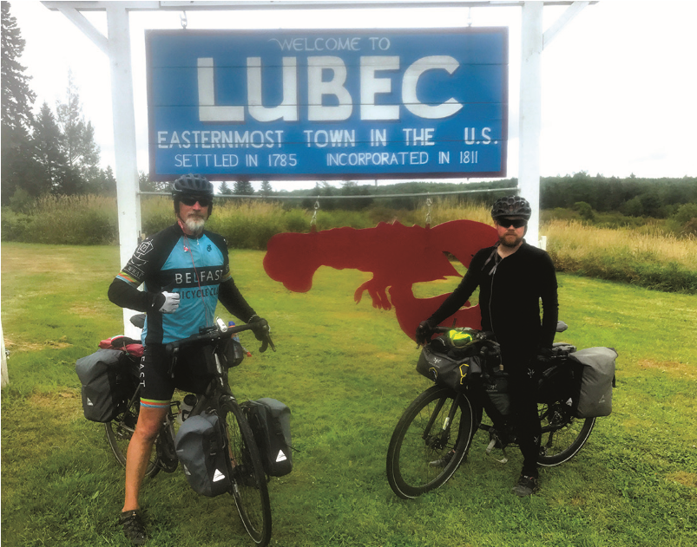
The Iris Network continues to inspire me and so many others to learn how to do just that. Through customized, thoughtful programs like in-home vision rehabilitation and technology and equipment training, people with vision loss can overcome their own “no you can’ts.”
The Iris Network teaches self-advocacy and leadership skills that allow anyone—from an aging senior who wants to maintain their check book register, to a young person Michael and riding partner posing in seeking their first job—to challenge their front of Lubec, Maine welcome sign. visual impairment.
With your gift today, you will be an advocate who inspires people with vision loss to live a life beyond a mere existence. From the bottom of my heart and on behalf of everyone The Iris Network serves, thank you in advance for your life-changing gift of “yes you can.”
Most Sincerely,
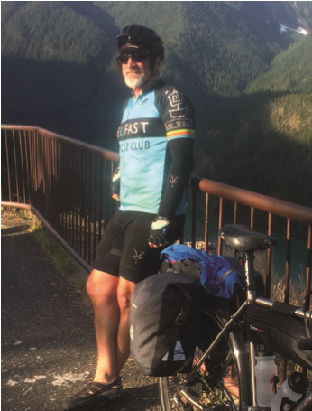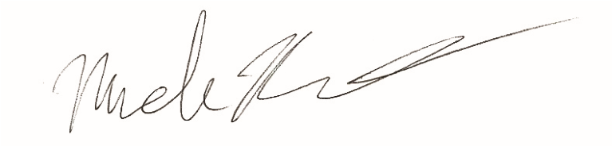
Michael Robertson
P.S. I hope you will be a supporter of The Iris Network and people like me—people who must learn through methods and tools that cater to our vision loss. I can’t stress enough how unique and valuable their services are. Please make your gift today!

